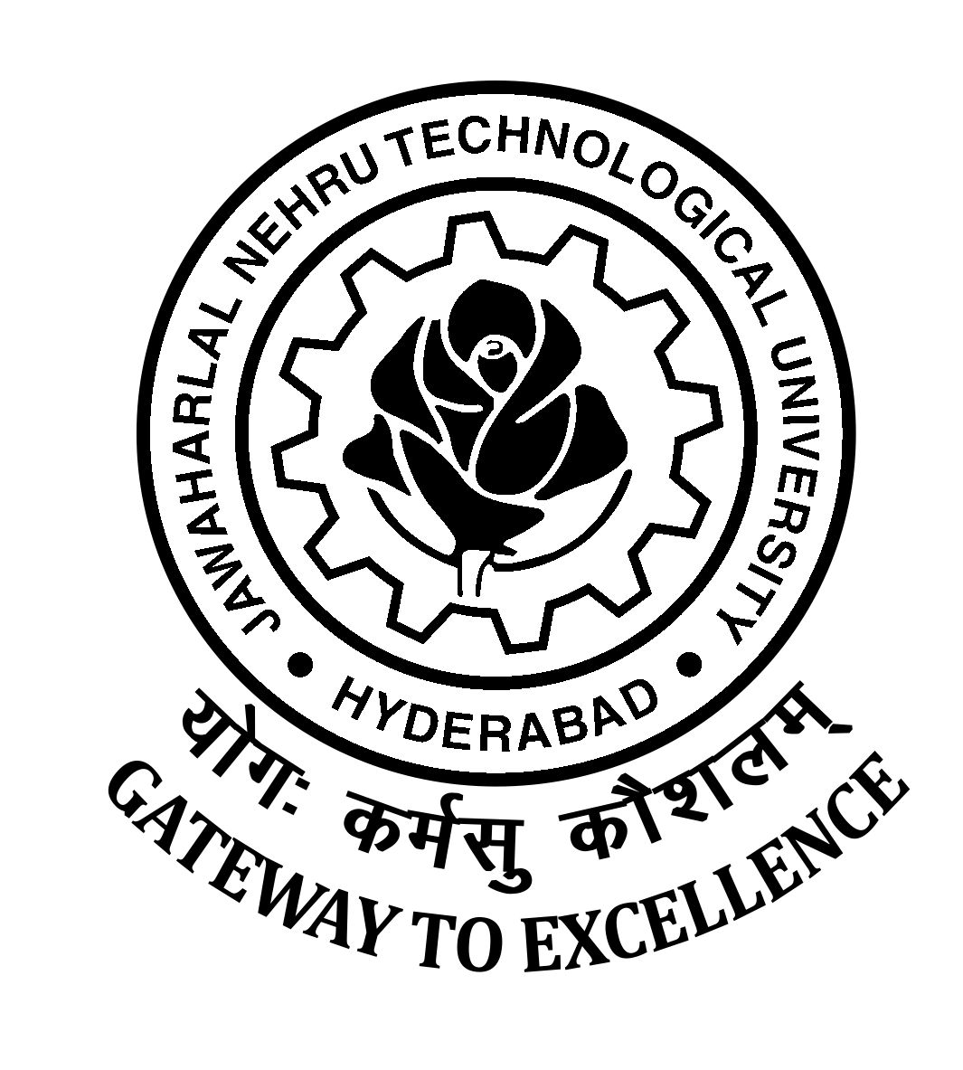
JAWAHARLAL NEHRU TECHNOLOGICAL UNIVERSITY HYDERABAD
KUKATPALLY, HYDERABAD – 500 085

Ph.D./M.S. – 2017-18 (Part Time) dt. 06.10.2018

Instructions to the candidates and issue of admission letter

*****

The provisionally selected candidates those who were reported as per the schedule on or before 15.09.2018 are directed to collect the admission letter on any day 23rd , 24th and 25th October, 2018 from the Office of the Directorate of Admissions, JNTUH, Kukatpally, Hyderabad – 85. by submitting the following originals certificates, Tuition Fee for first year only and Admission Fee .

Original Certificates for submission:
- S.S.C.
- Degree Certificate
- Post Graduate Certificate (OD)
- Post Graduate Consolidated Marks Memo
- Candidates who are qualified NET/TSSET/APSET/GATE(Valid)/M.Phil as per the norms are required to produce % of marks memo and Certificate
- Candidates belong to BC/SC/ST category are required to produce the latest Caste Certificate issued by competent authority from Telangana State.
- Transfer Certificate from previous college where the candidate studied.

Fee to be paid : (1) Tuition Fee of Rs.30,000/- through challan form

(2) Admission Fee of Rs.1500/- through challan form

(Challan form will be issue in the Office of the Directorate of Admission to pay the above fee in SBI, JNTUH Campus branch)

Sd/-
DIRECTOR, ADMISSIONS

