#



Organizing Committee Chief Patron

**Sri. Jayesh Ranjan IAS**

I/c Vice Chancellor, JNTUH

Patrons

**Prof. A. Govardhan**, Rector, JNTUH

**Prof. N. Yadaiah**, Registrar, JNTUH

President

**Dr. B. Venkateswara Rao,** Director, IST, JNTUH

Chairman

**Dr. C. Veerender,** Consultant Psychologist UHC-JNTUH

Convener

**Dr. S. Shobha Rani,** Assoc. Professor Head, CPS, IST, JNTUH,

In-charge- UHC

Address for Correspondence

**University Health Centre**

Jawaharlal Nehru Technological University Hyderabad

Kukatpally, Hyderabad - 500 085 Telangana State, INDIA,

Phone: 9866775259

**E Mail:** [***satlashobharani @gmail.com***](mailto:satlashobharani@gmail.com)



**About JNTU Hyderabad**

Jawaharlal Nehru Technological University, Hyderabad, aspires to be recognized as India’s most prestigious University. JNTUH has a progressive outlook and aims to offer the best possible education in Engineering, Science & Technology, Management and Foreign relations. JNTUH has recognized with “A grade by NAAC”

JNTU was established in the year 1972 and further divided into 4 universities in 2008 and renamed as JNTUH. Apart from its four prestigious colleges at Hyderabad, Jagityal, Manthani and Sultanpur, nearly 300 Engineering and Pharmacy colleges are affiliated to JNTU Hyderabad.

It also constitutes School of Information Technology, School of Continuing and Distance Education, UGC-HRDC, Bureau of Industrial Consultancy Services and Double Degree Programmes at PG level, in addition to M.S.,

M. Phil., Ph.D. Research Programmes in various disciplines of Engineering, Science & Technology (Water, Environment, Biotechnology, Pharmacy, Nanotechnology, Remote Sensing and Atmospheric Sciences), Management and Humanities.

**About University Health Centre:**

The University has provided a well sophisticated Health Centre building headed by a full-time doctor working on deputation from the Government Service and supported by a Pharmacist and staff to cater the medical needs of the students and employees of University.

The centre also has visiting doctors available on two days of a week (Gynecologist, Dentist, Psychologist, Ayurvedic, Homeopathic, and Physiotherapist). The Health centre has 4 General Wards, 7 Consultation rooms and a 6- bedded facility, an ambulance is also available round the clock to shift to nearby hospitals in case of emergency. The Health Centre also had tie up with 35 superspeciality hospitals on reimbursement basis.

"The counseling center is established in university to cater the needs of students to have good mental health, Career guidance, depression, anxiety and relationship issues will also be taken care to make the students better to progress in studies."



**Two- day workshop**

**On**

“KNOW YOUR STUDENT”

**(Adolescent problems and solutions)**

On

January 9th & 10th 2020

Chairman

**Dr. C. Veerender**, Consultant Psychologist

UHC-JNTUH

Convener

Dr. S. Shobha Rani**,** Assoc. Professor

Head, CPS, IST, JNTUH and In-charge- UHC

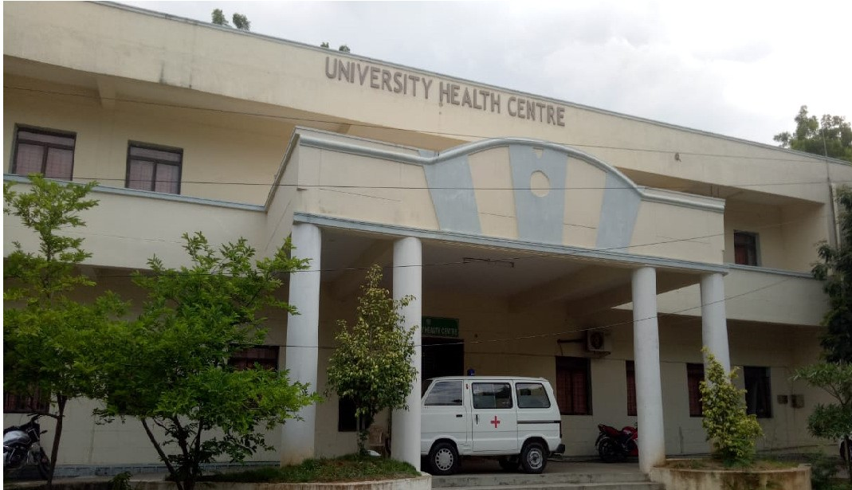

VENUE

UGC HRDC AUDITORIUM-JNTUH

Organized by

**University Health Centre (Counseling centre)**

**Jawaharlal Nehru Technological University Hyderabad** Kukatpally, Hyderabad - 500 085 Telangana State, INDIA

**Website:** [**http://www.jntuh.ac.in**](http://www.jntuh.ac.in/)



**Distinguished speakers and topics in the workshop**

* **Dr. C.Veerender**, Psychologist- Effective teaching skills & Love, friendship, attraction, How to guide the students.
* **Prof. Padmaja**, Psychologist, HCU – Addiction of mobile/ game/ internet, solution to overcome from addiction.
* **Dr. Purnima Nagraj**, Psychiatrist – Stress due to peer pressure, suicidal issues, adolescent depression and life skills.
* **Prof. Pratap Reddy**, ECE, JNTUH – How to improve teaching skills with technology.
* **Mr. Vishes**, Psychologist – Behavioral problem & How to make them better, skills to the lecturers
* **Mr. Kashyap kompella**, Director of EDWISE- Career, goal setting, thinking skills.
* **Sri Rajendra Prasad**, Money Specialist – How to understand the money, helping students to improve financial literacy.
* **Sri. Bal Reddy**, Personality development trainer – Lovable, conscious parenting of the faculty.
* **Dr. C.Veerender**, Psychologist – How to beat loneliness and impact of social media.

**Registration:**

Faculty of JNTUH and Affiliated colleges Rs.1250/- Last date for Registration

**4th January, 2020**

Mode of Payment to be paid in favor of'

**“Convener, know your student - 2020"**, payable at Hyderabad by Cash/ Demand Draft drawn from any nationalized Bank.

Registration form can be submitted to convener on or before 4th January, 2020. Registration forms can be photocopied if required.

**NOTE:**

* Registration is mandatory for all delegates.
* Registration fee includes lunch and participation certificate
* No cancellation or refunds shall be allowed.
* No transport.
* Accommodation on payment basis



**About the Workshop:**

India is a country of young population. Children and adolescents comprise the major part of our population. With rapidly changing socio-economic cultural environment there is a need to keep ourselves updated with the current problems faced by young people? All psychologists, teachers have a huge responsibility of steering our great country to the pinnacle of glory. By providing quality teaching we all can empower our next generation.

Teenage is a stage where a person faces and experiences many biological and psychological changes. This is the stage where a child gets into emotional bonding and gets attracted to the opposite sex so easily. At the age of sixteen where they just complete their schooling, they want to have their own world of freedom.

For a large number of teenagers, a violent or unhealthy relationship is their everyday reality. Attraction is natural at this stage but needs a proper judgment about the other person. Many are either unaware of the fact that it is a must to judge the person (especially opposite sex).

Since the globalization is showing great impact on our daily, the technology reached very nearer to the common man, the teenagers took up the technology to their chest and getting into the addiction to chatting, net browsing, online games, online bettings, pornsites and all other vices in spite of the regular monitoring by the parents and teachers. We have been seeing lying, stealing, having habits of boozing, smoking and using drugs etc they are intruded into youth life in the society.

There is a lot of confusion and suspicious atmosphere prevailing among the youth in the society. Teenage is a perfect stage where we lay path to bright future by acquiring skills and talents. But, at present the youth is in confusion. Every year, around 3000 students commit suicide and physical attacks on girls, due to misinterpretation of relationships, misunderstanding and depression. We would like to bring awareness on student issues among the teachers, professors and lecturers. This will help them in dealing with crises in life and to face the challenges in life and be successful in this competitive World. This conference is aimed at addressing these issues towards a bright society.



**Registration Form**

**Name of the Faculty:**

**Gender: M / F Designation:**

**Organization:**

**Address:**

**Contact No:**

**E-Mail ID:**

**Signature of the Applicant**

**Signature of**

Principal with Seal

**Note: Please Bring Photo Copy of Registration form on the Day of Conference**