Cell No. 9849359474
Email: dilnelli@gmail.com
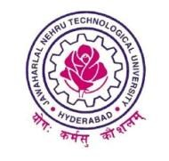
JAWAHARLAL NEHRU TECHNOLOGICAL UNIVERSITY HYDERABAD
College of Engineering, jagtial-505327

Dr. N.S. Dileep Date: 06/11/2017
Secretary(ICGS),
JNTUH Sports Council,
Kukatpally, Hyderabad.
To
The Principal,
Constituent & affiliated Colleges,
JNTUH Hyderabad.

Sir,
I submit that the following JNTUH team selections will be held as per the dates given below

S.No | Event | Section | Date | Reporting Time | Venue
1 | Kabaddi | Women | 10/11/2017 | 1:00pm | Mini Stadium, jagtial (Dist.)
2 | Athletics | (M&W) | 19/11/2017 | 8:00am | St. Martin’s Engg. College, Hyd.

The participants are requested to bring the following documents
• 10th Class marks memo (Xerox) duly signed by the Principal of the college
• Intermediate marks memo (Xerox) duly signed by the Principal of the college
• College I D Card Duly signed by the Principal of the college
• Eligibility form duly signed by the principal of the college
• University will not provide any equipment you are requested to bring your own equipment
Yours Sincerely
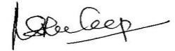
SECRETARY

