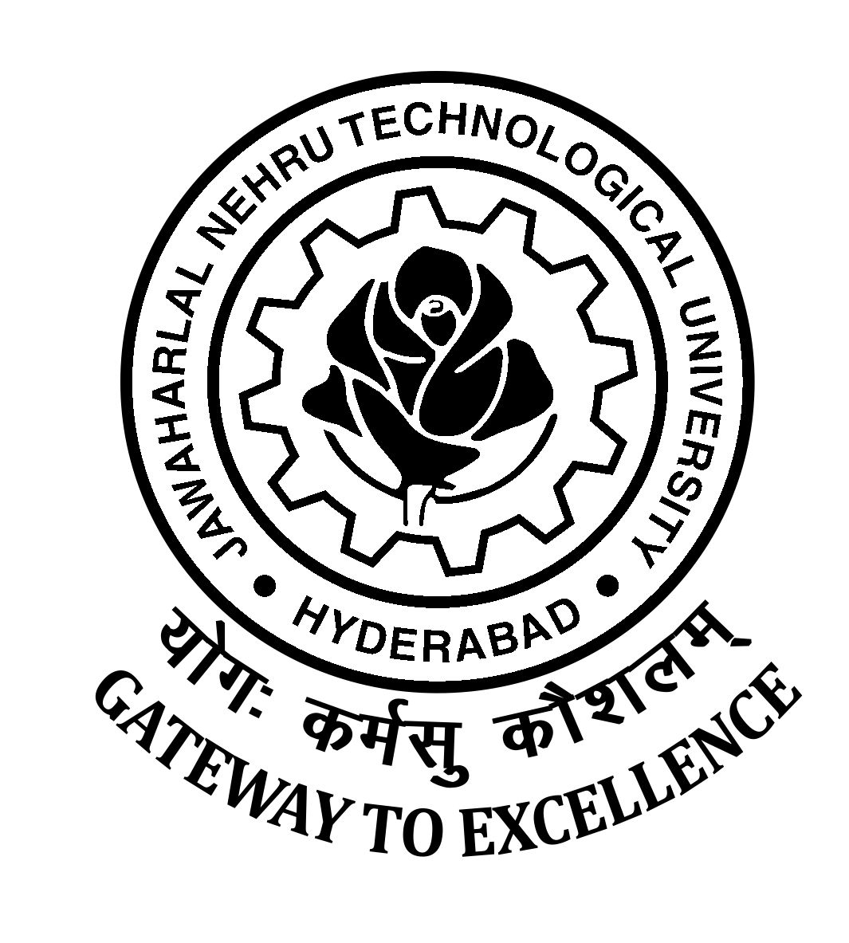

JAWAHARLAL NEHRU TECHNOLOGICAL UNIVERSITY HYDERABAD
KUKATPALLY, HYDERABAD – 500 085, TELANGANA STATE, INDIA

ADMISSION TO PART TIME P.G. PROGRAMS – 2019-20

Entrance Examination Time Table

The following disciplines have Entrance Examination as per schedule:

Dt: 22.07.2019

11.00 AM to 12.00 NOON

M.Tech. (Structural Engg)

Dt:24.07.2019
11.00 AM to 12.00 NOON

M.Tech (Environmental Management)

Note: Hall Tickets will not be posted to the candidates. It is the responsibility of the candidates to collect the Hall Tickets on 19th and 20th July, 2019 from the Office of the Director, Admissions, JNTUH, Kukatpally, Hyderabad without which he/she will not be allowed for the Entrance Examination

Note : Entrance Examination results will be available in JNTUH web site www.jntuh.ac.in.

There is no Entrance Examination for the following subjects. The admission will be directly through counseling as per eligibility only.

Sl.No. | Subject
1. | M .Tech.(Advanced Manufacturing Systems)
2. | M.Tech.(Computer Science)
3. | M.B.A. (HR/Finance/Marketing/Systems)
4. | M.Tech.(Industrial Metallurgy)

The following subjects are not considered for admission this year due to administrative reasons. The applied candidates are requested to collect back the registration fee demand drafts from the Office of the Director, Admissions, JNTUH, Kukatpally, Hyderabad between 10.30 am. To 5.00 p.m.
Sl.No. | Subject
1. | M.Tech.(Electrical Power Engg.)
2. | M.Tech.(Energy Systems)
3. | M.Tech.(Systems & Signal Processing)
4. | M.Tech.(Bio Technology)

Sd/-
DIRECTOR, ADMISSIONS

